

Suppose that you are Buzz Lightyear and want to return to your planet of origin. You gather your software development team is responsible for deploying a system for space exploration that should lead you to your destination. At the same time, however, the mission proves to be daunting due to the immense resources and complexity that are involved in the creation of your software system.

For this case study, you will get into groups to simulate a team of developers working on this program, you will follow along with the sections below and provide answers for each of the questions.

You will use these answers to guide you as you individually sketch process maps like the example below. Once you have all completed your sketches, you should combine your ideas into a final process map and create it using a tool such as [draw.io.](https://app.diagrams.net/).

Feel free to add as many branches and bubbles as you would like, but the process map must include the main six stages mentioned below. After you complete the final process map, your team will present it to the class.

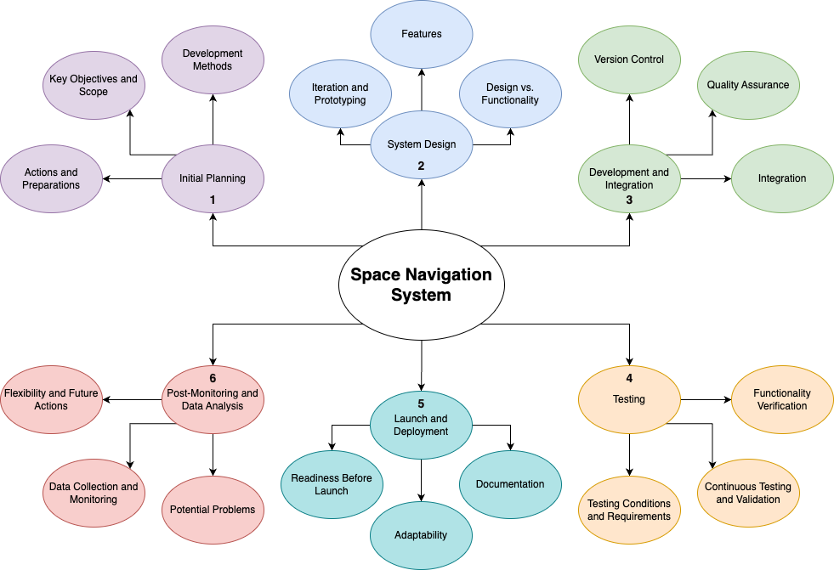

**Stage 1: Initial Planning**

1. What actions should the team take in the initial planning stage to prepare for the mission?
2. What are the key objectives and scope of the project at the moment? Are they likely to change?
3. Which development method aligns with a mission of this scale? Why?

**Stage 2: System Design**

1. Which design methodology is most appropriate for iterating and prototyping in the context of space exploration? (There are multiple correct answers, but they must be justified).
2. List (do not explain) the possible features of the spacecraft’s software that the team would need to take into account for development. What type of methodology would be best for this task? Why would you choose this methodology?
3. Are there any trade-offs between design and functionality that the team should consider at this stage of the project?

**Stage 3: Development and Integration**

1. What role would version control play in the development of the spacecraft’s software components?
2. What procedures could you utilize within the program development cycle to ensure that the various systems within the spacecraft work properly (quality assurance)?
3. How should the components of the spacecraft be integrated? Should they be integrated one by one or all at once?

**Stage 4: Testing**

1. How would test cases help you verify that the spacecraft can function in the harsh conditions of a distant galaxy?
2. Which development method is best for continuous testing and validation processes?

**Stage 5: Launch and Deployment**

1. By this stage of the mission, what types of documentation would you have already written?
2. How do you address any last-minute challenges or adjustments before launch? Which development method aligns with maintaining adaptability and readiness leading up to the launch?

**Stage 6: Post-launch Monitoring and Data Analysis**

1. What actions should the team take after the spacecraft is launched and is on its way to its destination? Could there be potential problems with the design methodology used until now?
2. How would you continuously monitor the spacecraft's performance and collect data from the mission? What would this data tell you in terms of the team’s next actions?
3. Which development method would facilitate flexibility and ongoing data analysis for space exploration missions?

**Part 2**

With your partner, use Draw IO to map out your possible software development process to make predictions for a certain artist or sport to find the next new talent.